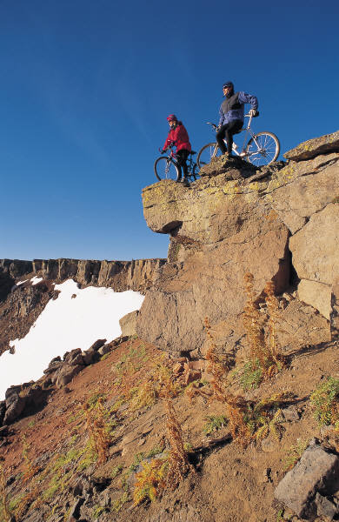

When: 8/1/17 – 8/8/17

Where: Vail, CO

Price: $1,000

555.444.3333

# Boy Scouts in Vail

### Reason 2 Go presents…